

**I VOLUNTEER SOCIAL NETWORK**

**DETAIL DESIGN DOCUMENT**

**Data Design**

**Project Code: IVSN**

**Document Code: IVSN_Data Design_v1.1_EN**

**Record of Change**

*A-Added M-Modified D-Deleted

|  |  |  |  |  |
| --- | --- | --- | --- | --- |
| Date | Item | A, M, D* | Change Description | Version |
| 2016/06/14 | Add new | A |  | V1.0 |
| 2016/07/20 | Overview  Entity Relationship Diagram | M |  | V1.1 |

Table of Contents

1. Introduction 4

1.1. Purpose 4

1.2. Definitions, Acronyms and Abbreviations 4

1.3. References 4

1.4. Overview 4

2. Database 4

2.1. Entity Relationship Diagram 4

2.1.1. Entity Description 7

2.1.2. Relationship 7

2.2. Table Diagram 8

2.2.1. User Table 8

2.2.2. Comment Table 10

2.2.3. Conversation Table 10

2.2.4. Message Table 10

2.2.5. Notification Table 10

2.2.6. Post Table 11

2.2.7. Place Table 11

2.2.8. Photo Table 11

2.2.9. Video Table 12

2.2.10. Room Table 12

2.2.11. Report Post table 12

2.2.12. Report User table 13

# Introduction

## Purpose

I Volunteer Social Network data design document describes structure of database and file structure of system including internal file structure as well as interface file structure.

## Definitions, Acronyms and Abbreviations

|  |  |  |
| --- | --- | --- |
| Abbreviations | Description | Comment |
| IVSN | I Volunteer Social Network |  |

## References

|  |  |
| --- | --- |
| Documen | Title |
| Class Design Document | IVSN_Class Design_v1.0_EN |
| Architecture Design | IVSN_Architecture Design_v1.2_EN |
| Software Requirement Specification | IVSN_Software Requirement Specification_v1.2_EN |

## Overview

This document describes relationship between entities and properties of each entity.

# Database SQL

## Entity Relationship Diagram

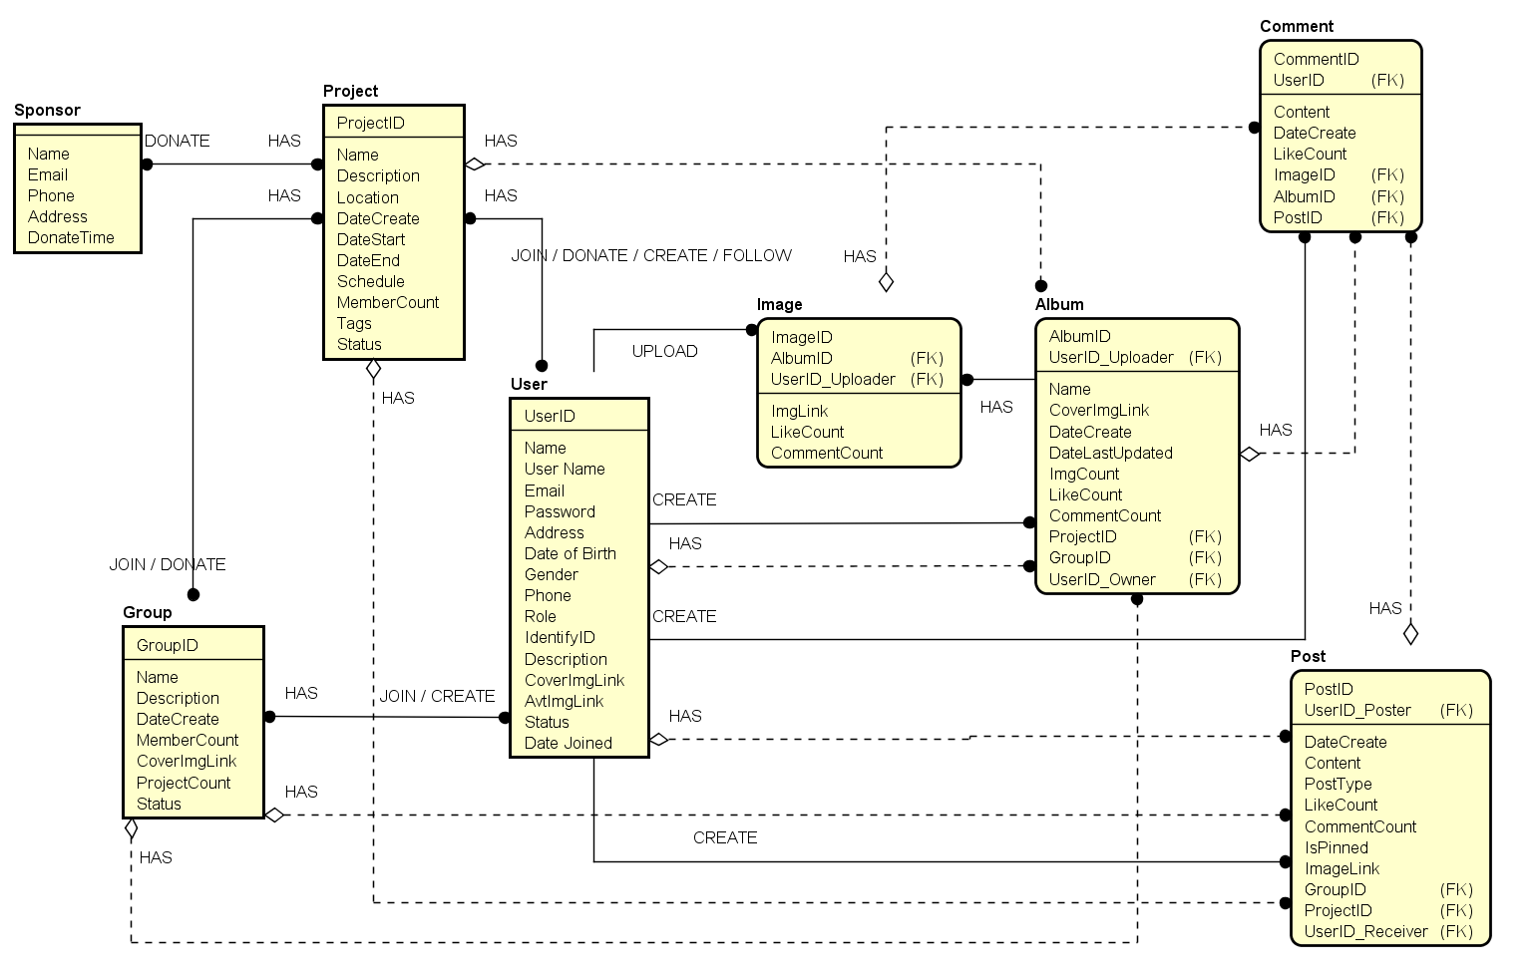

*Entity Relationship Diagram part 1*

*Entity Relationship Diagram part 2*

### Entity Description

|  |  |  |
| --- | --- | --- |
| No. | Entity | Description |
|  | User | User is all people who registered and using IVSN |
|  | Post | A post which user published, contain content, photos. |
|  | Album |  |
|  | Image | Image(s) which user attached in a post while creating |
|  | Sponsor |  |
|  | Project |  |
|  | Group |  |
|  | Comment | A comment which user created, is placed in and associated to a post |

### Relationship

|  |  |  |  |  |  |
| --- | --- | --- | --- | --- | --- |
| No. | Relation | Properties | From | To | Description |
|  | DONATE | None | Sponsor | Project |  |
|  | DONATE | None | Group | Project |  |
|  | JOIN | None | Group | Project |  |
|  | JOIN | None | User | Group |  |
|  | CREATE | None | User | Group |  |
|  | CREATE | None | User | Project |  |
|  | FOLLOW | None | User | Project |  |
|  | JOIN | None | User | Project |  |
|  | DONATE | None | User | Project |  |
|  | UPLOAD | None | User | Image |  |
|  | CREATE | None | User | Album |  |
|  | CREATE | None | User | Post |  |
|  | CREATE | None | User | Comment |  |

### Entity Detail

* + - 1. Sponsor

|  |  |  |  |  |
| --- | --- | --- | --- | --- |
| No | Attribute | Type | Mandatory | Description |
|  | Sponsor ID | Number | Y | Sponsor’s id |
|  | Name | Number | Y | Sponsor’s name |
|  | Email | String | Y | Sponsor’s email |
|  | Address | String | Y | Sponsor’s address |
|  | Phone | Number | Y | Sponsor’s phone |
|  | Donate Time | Number | Y | Sponsor’s donate time |

#### Project

|  |  |  |  |  |
| --- | --- | --- | --- | --- |
| No | Field Name | Type | Mandatory | Description |
|  | Project ID | Number | Y | Project’s id |
|  | Name | String | Y | Project’s name |
| 3 | Description | String | Y | Project’s description |
| 4 | Location | String | Y | Project’s location |
| 5 | Date Created | Date | Y | Project’s date created |
| 6 | Date Start | Date | Y | Project’s date start |
| 7 | Date End | Date | Y | Project’s date end |
| 8 | Schedule | String | Y | Project’s schedule |
| 9 | Member Count | Number | Y | Project’s member count |
| 10 | Tags | String | Y | Project’s tags |
| 11 | Status | Number | Y | Project’s status |

#### 2.2.1.3

|  |  |  |  |  |
| --- | --- | --- | --- | --- |
| No | Field Name | Type | Mandatory | Description |
|  | Group ID | Number | Y | Group’s id |
|  | Name | String | Y | Group’s name |
|  | Description | String | Y | Group’s description |
|  | Date Created | Date | Y | Group’s date created |
|  | Member Count | Number | Y | Group’s member count |
|  | Cover Img Link | String | Y | Group’s cover img link |
|  | Project Count | Number | Y | Group’s project count |
|  | Status | String | Y | Group’s status |

#### Post

|  |  |  |  |  |
| --- | --- | --- | --- | --- |
| No | Field Name | Type | Mandatory | Description |
|  | Post ID | Number | Y | Post’s id |
|  | Content | String | Y | Post’s content |
|  | Date Create | Date | Y | Post’s date create |
|  | User ID Poster | Number | Y | Post’s user id poster |
|  | Post Type | String | Y | Post’s post type |
|  | Like Count | Number | Y | Post’s like count |
|  | Comment Count | Number | Y | Post’s comment count |
|  | Is Pinned | Boolean | Y | Post’s is pinned |
|  | Image Link | String | Y | Post’s image link |
|  | Group ID | Number | Y | Post’s group id |
|  | Project ID | Number | Y | Post’s project |
|  | UserID Receiver | Number | Y | Post’s userid reciver |

#### Image

|  |  |  |  |  |
| --- | --- | --- | --- | --- |
| No | Field Name | Type | Default | Description |
|  | Image ID | Number | Y | Image’s id |
|  | Album ID | String | Y | Image’s album id |
|  | UserID Uploader | Number | Y | Image’s user id uploader |
|  | Image Link | String | Y | Image’s link |
|  | Like Count | Number | Y | Image’s like count |
|  | Comment Count | Number | Y | Image’s comment count |

#### Album

|  |  |  |  |  |
| --- | --- | --- | --- | --- |
| No | Field Name | Type | Mandatory | Description |
|  | Album ID | Number | Y | Album’s id |
|  | User ID Uploader | String | Y | Album’s path |
|  | Date create | Date | Y | Album’s date created |
|  | Name | String | Y | Album’s name |
|  | Cover Image Link | String | Y | Album’s cover img link |
|  | Date Last Update | Date | Y | Album’s date last update |
|  | Image Count | String | Y | Album’s Image count |
|  | Like Count | Number | Y | Album’s like count |
|  | Comment Count | Number | Y | Album’s comment count |
|  | Project ID | Number | Y | Album’s project id |
|  | Group ID | Number | Y | Album’s group id |
|  | User ID Owner | Number | Y | Album’s userid owner |

#### Comment

|  |  |  |  |  |
| --- | --- | --- | --- | --- |
| No | Field Name | Type | Mandatory | Description |
|  | Comment ID | Number | Y | Comment’s id |
|  | Content | String | Y | Comment’s content |
|  | Date Created | Date | Y | Comment’s date created |
|  | User ID | Number | Y | Comment’s user id |
|  | Like count | Number | Y | Comment’s like count |
|  | Image ID | Number | Y | Comment’s image id |
|  | Album ID | Number | Y | Comment’s album id |
|  | Post ID | Number | Y | Comment’s post id |

#### User

|  |  |  |  |  |
| --- | --- | --- | --- | --- |
| No | Field Name | Type | Mandatory | Description |
|  | User ID | Number | Y | User’s id |
|  | Name | String | Y | User’s name |
|  | User Name | String | Y | User’s user name |
|  | Email | String | Y | User’s email |
|  | Password | String | Y | User’s password |
|  | Address | String | Y | User’s address |
|  | Gender | String | Y | User’s gender |
|  | Phone Number | String |  | User’s phone number |
|  | Date of Birth | Date | Y | User’s date of birth |
|  | Identify ID | String | Y | User’s identify id |
|  | Status | String | Y | User’s status |
|  | Date Joined | Date | Y | User’s date joined |
|  | Role | String | Y | User’s role |
|  | Description | String | Y | User’s description |
|  | Cover Img Link | String | Y | User’s cover img link |
|  | Avt Img Link | String | Y | User’s avt img link |

# Database MongoDB

## Entity Diagram

